5/19/2021

Nadir Hussain

023-18-0025

Computer Networks

Lab 09

**Lab Objectives**

* Configure Virtual Local area network using eNSP, practice commands and ping from one VLAN to another VLAN.
* Configure Virtual Local area network using eNSP, and make them communicate by VLAN inter-VLAN routing technique. Create sub interfaces using one router.

Configure Virtual Local area network using eNSP, practice commands and ping from one VLAN to another VLAN.

Switches can be used to create local area networks.

Why do we need VLAN?

* Physically we may be connected to any local area network, but we can virtualy connect to desired network.

**Network Design**

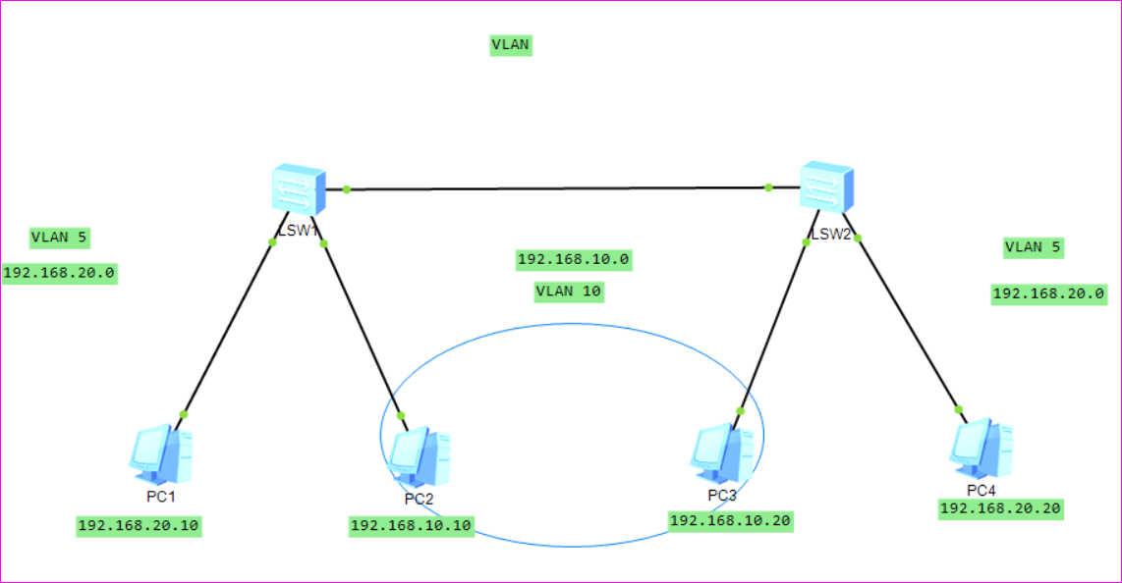

Physically we have one local area network, but we can not connect PC2 and PC3 physically i.e they maybe in different buildings so we create VLAN. PC2 and PC3 are parts of VLAN5 while rest are part of VLAN10.

Now configure PCs statically.

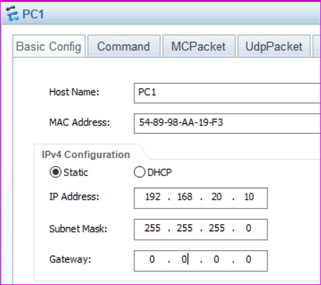

Similarly for PC2, PC3 and PC4

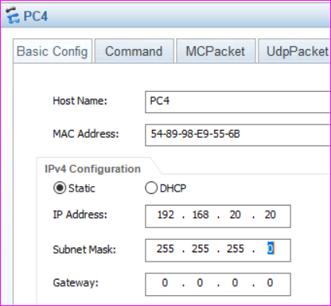

These PC1 and PC4 can ping each other, while PC2 and PC3 can connect to eachother. PC1 can’t ping to PC2 as network IP is different. But we haven’t yet configured virtualization.

PC2 and PC3 are to be isolated.

On Switch1

**First check if there is VLAN.**

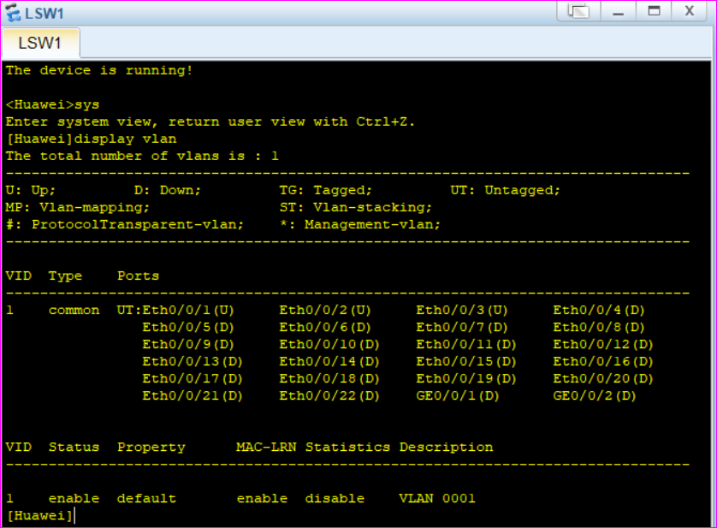

VLAN1 is already taken, so we change our VLANS to other name.

Now we create our own VLAN 5 and VLAN 10 on switch 1 and VLAN 5 and VLAN 10 on switch 2

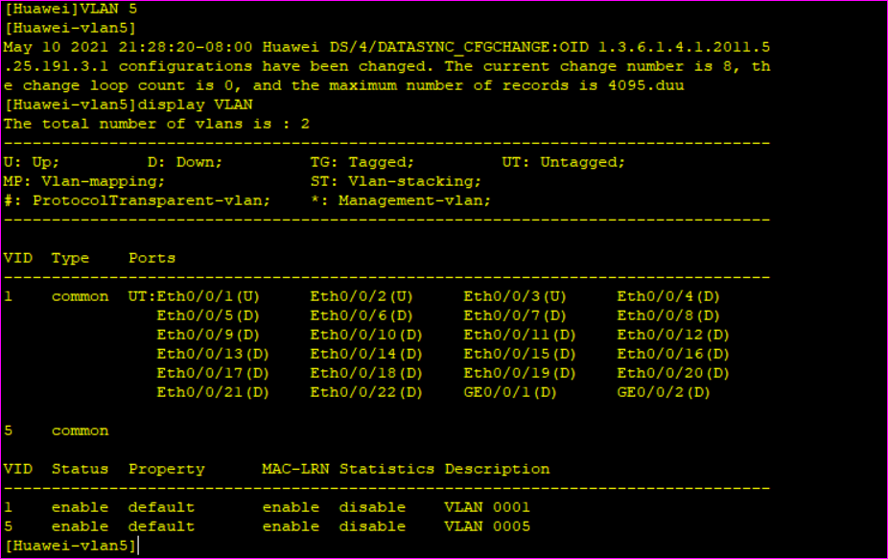

VLAN5 is created, we haven’t still configured ports.

We create another VLAN on same switch as VLAN10 for PC2

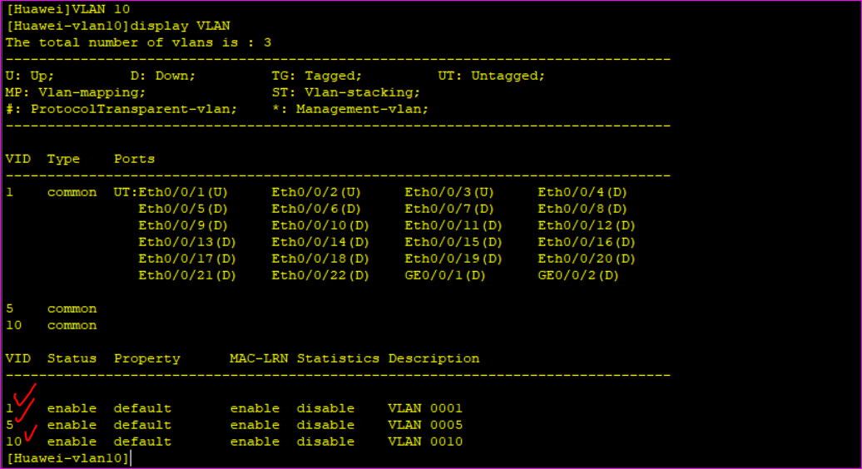

So VLAN 5 and VLAN 10 are created, but we haven’t configured PCs to VLANs.

PC1 is connected to port 0/0/1 and we need to define this as logical/access port on switch1

We need to define access point for PC1 and VLAN to which it belongs. It belongs to VLAN5

**On switch1**

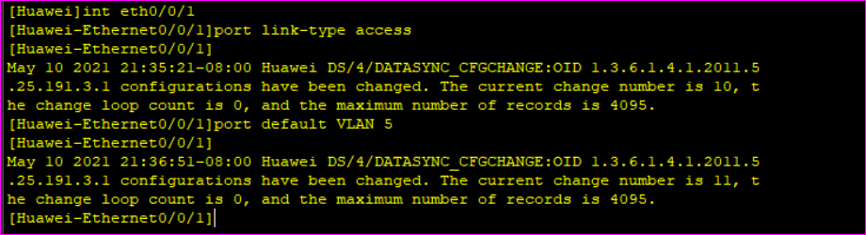

Now we display VLAN on Switch1

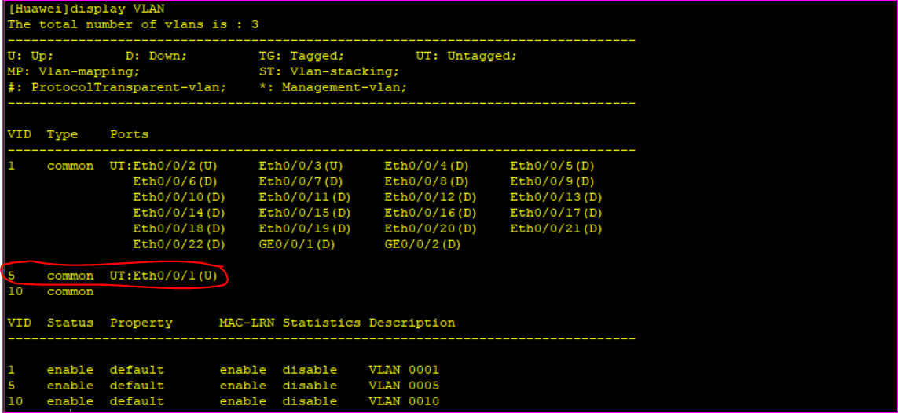

We can note that port 0/0/1 is representing VLAN5

Similarly we make eth0/0/2 as part of VLAN2 and define its type.

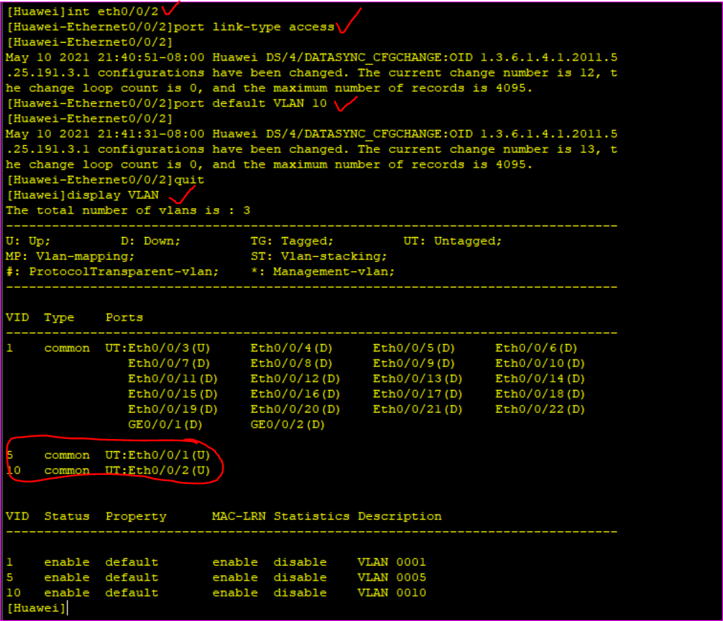

So we have created VLAN ports upto here on Switch 1

But eth0/0/3 is still remaining. It connects PC1 and PC2 to PC4 and PC3 respectively VLAN wise. So carries traffic from both VLANs, hence its type can’t be access. We define its type as trunk.

We make th0/0/3 as trunk, and tell to to it to allow all or few VLANs traffic.

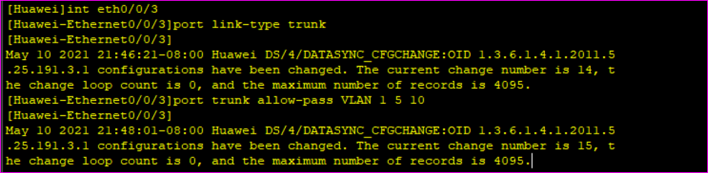

Or we can simply write port trunk allow-pass VLAN all, to allow traffic from all VLANs

We have completed configuration on Switch1, Now we Configure VLAN on Switch2

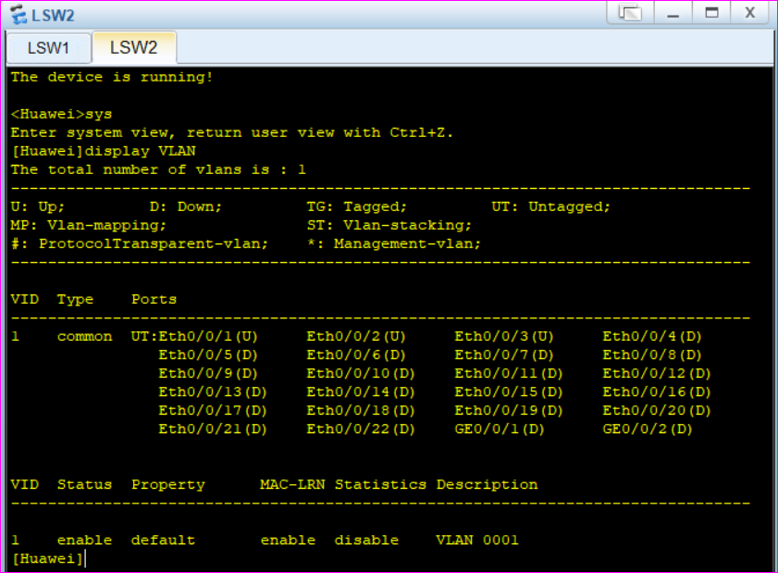

Only 1 VLAN here, we create VLAN5 and VLAN10

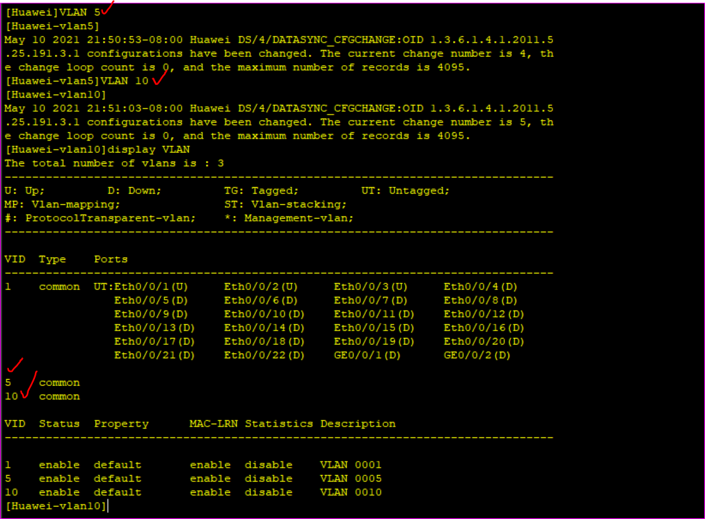

Now configure ports to VLAN.

Eth0/0/1 connects both switches

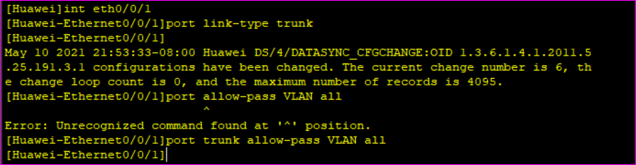

Port 0/0/2 and 0/0/3 are of type access. Port 2 is part of VLAN10 which is virtual/isolated.

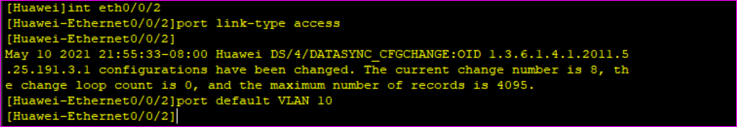

Port 3 is part of VLAN5

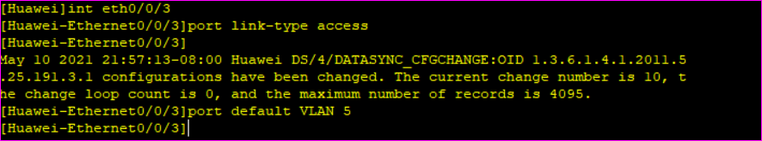

Now we display VLAN on switch2

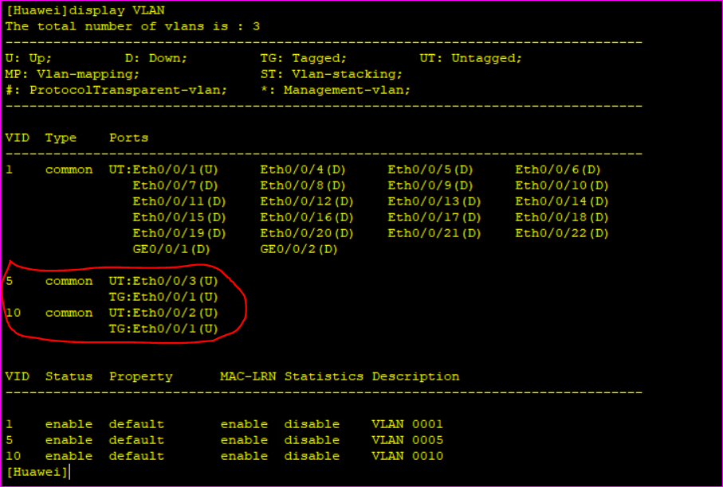

So we have completed configuration.

**Can we access PC2 from PC1?**

Lets ping.

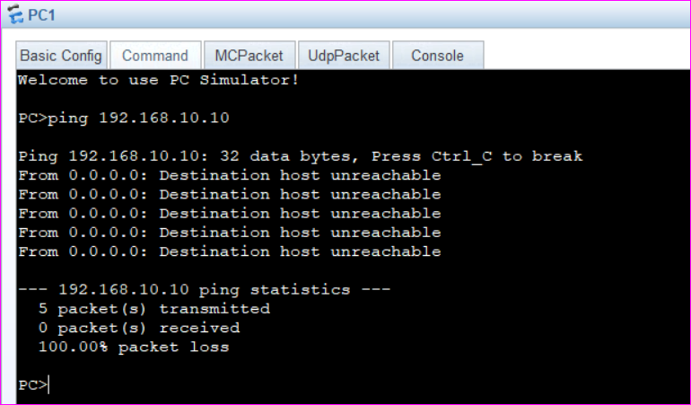

Even we have same network, but we have separated them virtually.

Let’s change the IP of PC2 to 192.168.20.30 and the ping. We are making them on same network.

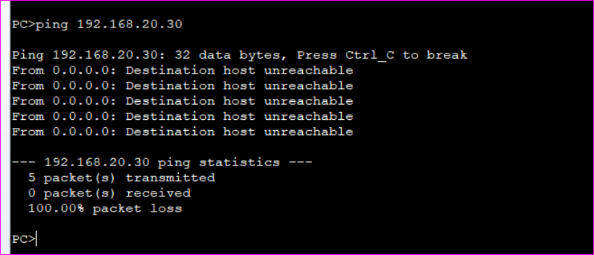

*So we have separated them and can’t communicate with each other even network is same. We could have ping without VLAN from PC1 to PC2 with above IP address.*

**PC1 can ping PC4 and PC2 can ping PC3 as their VLANs are same.**

**PC1 to PC4 i.e VLAN 5**

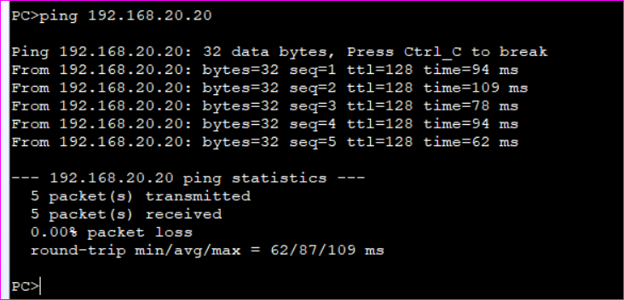

PC2 to PC3 i.e VLAN 5

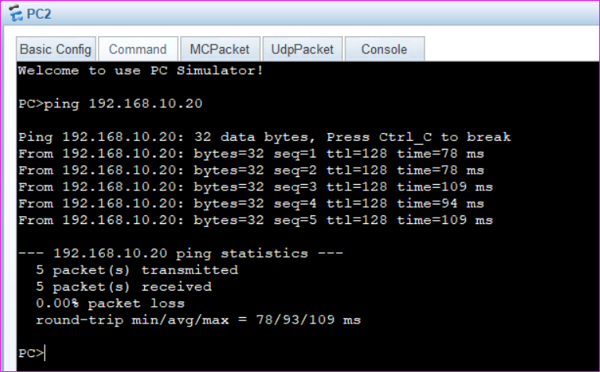

***But how to ping from one VLAN to another?***

**We will have to do inter-VLAN routing.**

We use a router to connect VLANs to it. But why use VLAN when we can create 2 networks with single router?

* Because We want to avoid too back and too short. We don’t want to create 2 networks, we want a single network but maintain the VLAN to access them as well.So we use one interface of router, we are actually doing “saving”.

**Configure Virtual Local area network using eNSP, and make them communicate by VLAN inter-VLAN routing technique. Create sub interfaces using one router.**

**Connect router to any switch**

**Network Design**

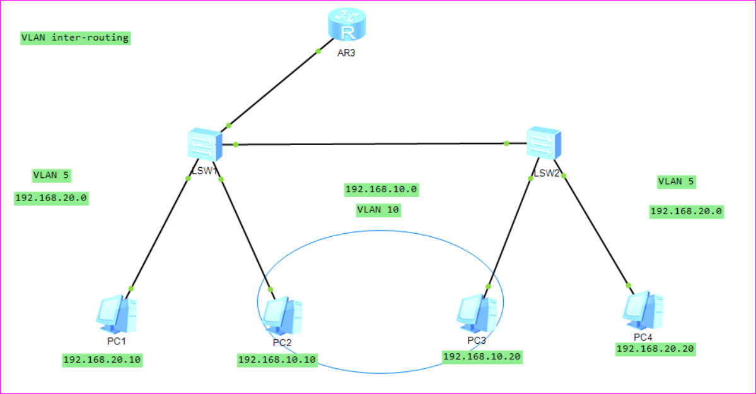

Now on router

We will create 2 sub interface of one interface connected to switch1.

1. For 192.168.20.0
2. For 192.168.10.0

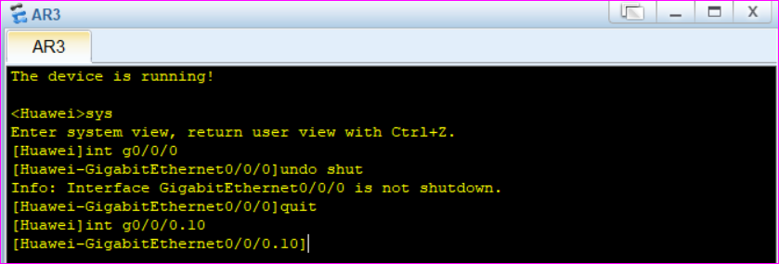

We have created sub interface for 10.0

***How to assign IP?***

To enable VLANs we use dot1q protocol, that supporst VLAN header information.

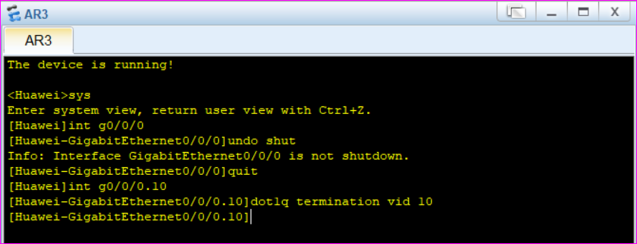

Now assign IP to this interface

We know its not network, its interface so Ip will be

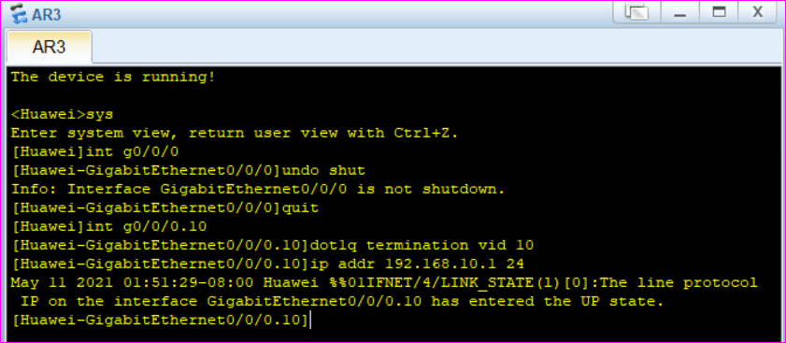

As we are using router for Layer2, and ARP broadcast is not supported by router, so we make it support.

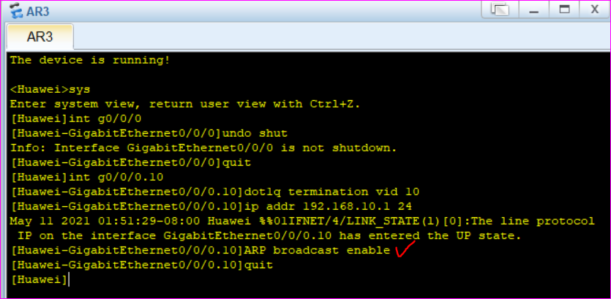

So we have simply created subinterface on router with enabled ARP broadcast.

**We do same for VLAN 5**

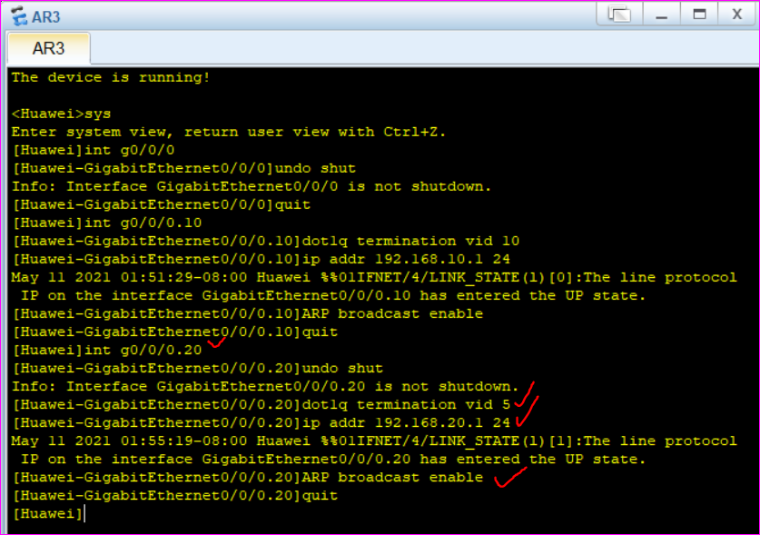

Now we should allow eth0/0/4 of Switch to allow all traffic to router. So

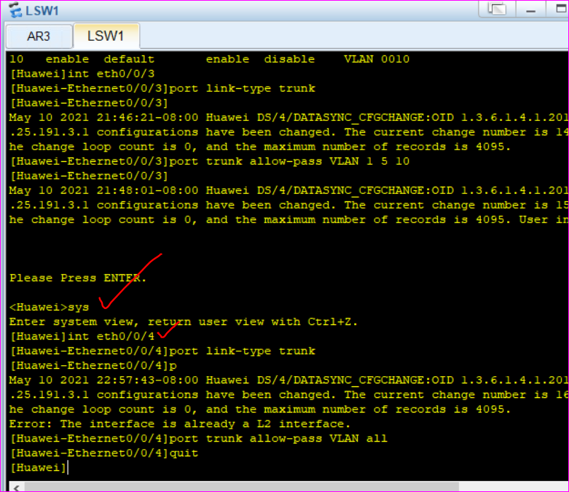

**Now we check if one VLAN can ping other or not.**

**From PC1 to PC2**

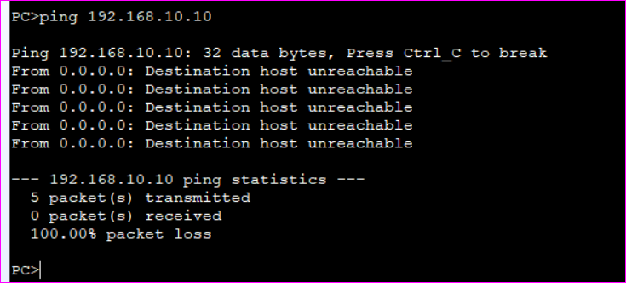

Still ping is failed.

We have to define the gateway for PCs now as they are connected to router via switch.

Router knows how to access VLAN 10, but PC1 don’t know router, so we assign gateway to all PCs.

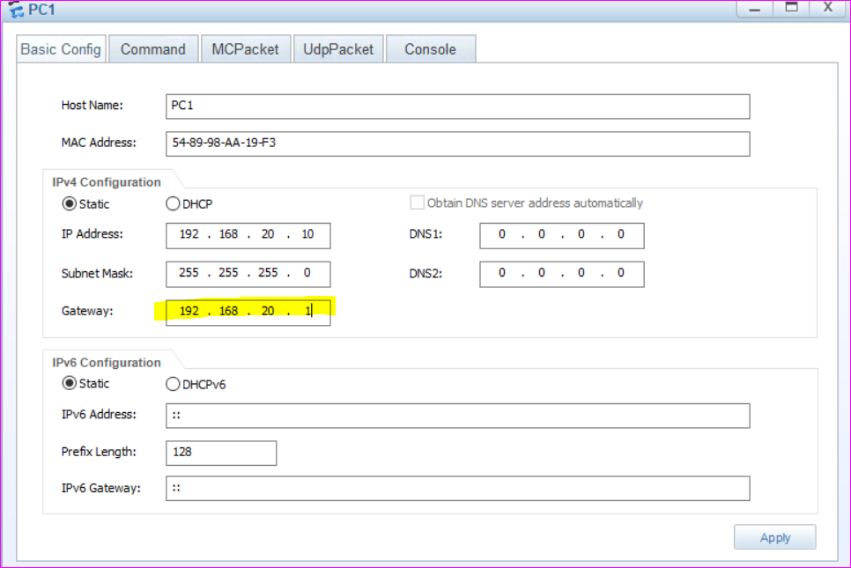

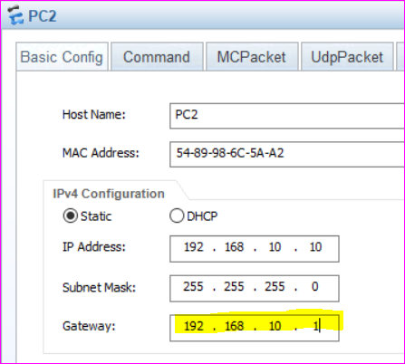

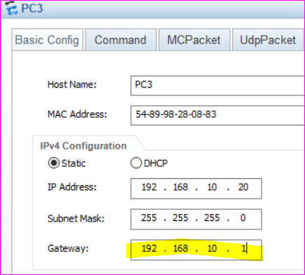

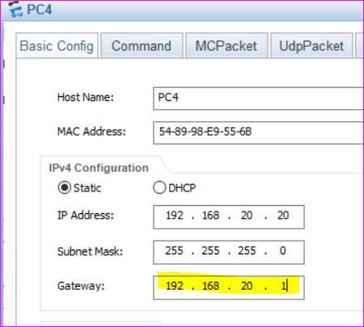

Now we again Ping from one VLAN to another VLAN.

**From PC1 to PC2 i.e VLAN5 to VLAN10**

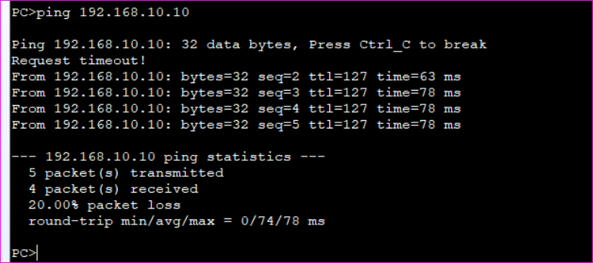

**From PC3 to PC1 i.e VLAN 10 to VLAN 5**

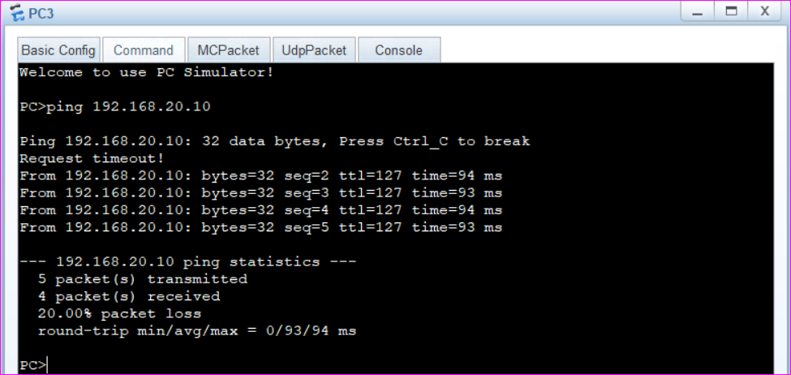

**Why request timeout for the first time?**

Because PC3 broadcasts on switch but switch doesn’t provide information about 192.168.20.10, so it goes to router and 1 ping msg is timed out.

So We created VLAN networks, connected the via router and they can communicate with each other via sub interface.

**The End**